**STOOGLE EXPRESS**

**(**A Web Application**)**

**MAJOR PROJECT REPORT**

**SUBMITTED IN PARTIAL FULFILLMENT OF THE REQUIREMENT FOR THE**

**AWARD OF THE DIPLOMA (CSE)**

**SUBMITTED BY:**

**AKANKSHA (506/16)**

**HARMANPREET SINGH (518/16)**

**NIMIT ARORA (527/16)**

**RUBALDEEP SINGH (538/16)**

**SAJAN SHARMA (540/16)**

**CSE 6TH**



**MEHR CHAND POLYTECHNIC COLLEGE**

**ACKNOWLEDGEMENT**

The satisfaction that accompanies the successful completion of any task would be incomplete without the mention of people whose ceaseless cooperation made it possible, whose constant guidance and encouragement crown all efforts with success.

I would like to take this opportunity to express my gratitude towards all the people who have in various ways, helped in the successful completion of my project. Many books are the result of a collection from various sources, such as internet, newspapers, magazines etc. Unfortunately, sources were not always noted or accurate acknowledgment.

Regardless, I am grateful to my friend, for his guidance, inspiration & constructive suggestions that helped me in the preparation & execution of this project.

**Table of Contents**

|  |  |  |
| --- | --- | --- |
| **Serial No.** | **Contents** | **Page No.** |
| 1. | Project Introduction | 4-5 |
| 2. | Modules in Project | 6 |
| 4. | About Languages used | 7-15 |
| 5. | About Database | 16-18 |
| 6. | Requirement Analysis | 18 |
| 7. | Data flow diagrams For Project | 19 |
| 8. | ER diagrams For Project | 20-22 |
| 9. | Screenshots of Project | 22-28 |
| 10. | Conclusion | 29 |
| 11. | References | 30 |
|  |  |  |
|  |  |  |

**INTRODUCTION TO PROJECT**

“STOOGLE EXPRESS” is basically a website for searching and finding jobs. Not only that, but students can look for various institutions/colleges for admission also. We have tried our best to make the process of searching and finding jobs and looking for various colleges or institutions a lot easier by combining the information and data of jobs and institutions together. We also have tried to design the website in such a way that the user may not have any difficulty in using the website. We also combine the data and information of jobs and institutions so that if job seeker is willing to work and study simultaneously or a student wants to study and work at the same time, then they don’t have to go somewhere else because our website is made for both of those purposes. In the most websites we have seen that the jobs are not categorized so in this website we categorized the jobs into different categories like Computer Engineering, Electronics Engg., Civil Eng., Automobile Eng., Mechanical Eng., Electrical Eng.



**OBJECTIVE**

* The sole aim of our project or say, our website is to provide an easy and friendly interface for the user to search for jobs and institutions.
* We also combine the data and information of jobs and institutions so that if job seeker is willing to work and study simultaneously or a student wants to study and work at the same time, then they don’t have to go somewhere else because our website is made for both of those purposes.
* We also provide feature that will also provide notes (freely downloadable) of various subjects to the students.
* In the most websites we have seen that the jobs are not categorized so in this website we categorized the jobs into different categories like Computer Engineering, Electronics Engg. , Civil Engg , Automobile Engg. , Mechanical Engg. , Electrical Engg.
* We also categorized colleges in three categories like Commerce, Engineering, and Pharmacy.
* We also provide basic information about technical events that are held in different colleges so that students will easily participate in it.

**DETAILED DESCRIPTION OF PROJECT**

As we know, nowadays finding a job or searching for an institution information has become sort of a headache because there are many false and misleading websites that distribute wrong and incorrect data and information about various things. So in order to fix that and provide necessary and genuine information about jobs and institutions, we have made our website.

In other words, we can also say that our website “STOOGLE EXPRESS” is a combined platform for Job Provider, job seeker and a normal student who is willing to get admission in a new institute or a college and wants to get basic information about it. For e.g. he/she wants to know about the infrastructure, departments, courses etc. provided by that institute.

We als provide notes of various subjects for the students in order to help them further. This will help the students to do their work when they are absent or if they happen to miss a lecture or more. This will also help them during exams for revision.

**MODULES IN PROJECT**

There are mainly two modules in our website which are:

1. **Employer\Institution Module:** In this module, the job provider can add information about the jobs and define the description of the various jobs. The information and data about various institutions is also added in this module.
2. **Job Seeker Module:** In this module, the job seeker can have a look for various jobs and can apply for it as per his/her choice.
3. **Student Module:** This module includes the data and information about various institutions like their infrastructure, departments, courses etc.

**TECHNOLOGIES USED IN PROJECT**

**Front End 🡪** HTML, CSS, JAVASCRIPT, BOOTSTRAP

**Back End 🡪** PHP (for development with MySQLi Database), JavaScript (for applying validations)

**Database 🡪** MySQL (with XAMPP Server)

**Text Editor 🡪** Sublime Text

1. **PHP (**Hypertext Preprocessor or Personal Home Page**)**

.

**Hypertext Preprocessor** (or simply **PHP**) is a [server-side scripting](https://en.wikipedia.org/wiki/Server-side_scripting) language designed for [Web development](https://en.wikipedia.org/wiki/Web_development), but also used as a [general-purpose programming language](https://en.wikipedia.org/wiki/General-purpose_programming_language). It was originally created by [Rasmus Lerdorf](https://en.wikipedia.org/wiki/Rasmus_Lerdorf) in 1994, the PHP [reference implementation](https://en.wikipedia.org/wiki/Reference_implementation) is now produced by The PHP Group. PHP originally stood for Personal Home Page, but it now stands for the [recursive initialism](https://en.wikipedia.org/wiki/Recursive_initialism) PHP: Hypertext Preprocessor.

PHP code may be embedded into [HTML](https://en.wikipedia.org/wiki/HTML) code, or it can be used in combination with various [web template systems](https://en.wikipedia.org/wiki/Web_template_system), web content management systems, and [web frameworks](https://en.wikipedia.org/wiki/Web_framework). PHP code is usually processed by a PHP [interpreter](https://en.wikipedia.org/wiki/Interpreter_(computing)) implemented as a [module](https://en.wikipedia.org/wiki/Plugin_(computing)) in the web server or as a [Common Gateway Interface](https://en.wikipedia.org/wiki/Common_Gateway_Interface) (CGI) executable. The web server combines the results of the interpreted and executed PHP code, which may be any type of data, including images, with the generated web page. PHP code may also be executed with a [command-line interface](https://en.wikipedia.org/wiki/Command-line_interface) (CLI) and can be used to implement [standalone](https://en.wikipedia.org/wiki/Computer_software) [graphical applications](https://en.wikipedia.org/wiki/Graphical_user_interface).

PHP/FI could be used to build simple, dynamic [web applications](https://en.wikipedia.org/wiki/Web_application). To accelerate [bug](https://en.wikipedia.org/wiki/Software_bug) reporting and improve the code, Lerdorf initially announced the release of PHP/FI as "Personal Home Page Tools (PHP Tools) version 1.0" on the [Usenet](https://en.wikipedia.org/wiki/Usenet) discussion group *comp.infosystems.www.authoring.cgi* on June 8, 1995. This release already had the basic functionality that PHP has today. This included [Perl-like variables](https://en.wikipedia.org/wiki/Local_variable#Local_variables_in_Perl), form handling, and the ability to embed HTML. The [syntax](https://en.wikipedia.org/wiki/Syntax) resembled that of Perl, but was simpler, more limited and less consistent.

### PHP Version History

The fact that PHP was not originally designed, but instead was developed organically has led to inconsistent naming of functions and inconsistent ordering of their parameters. In some cases, the function names were chosen to match the lower-level libraries which PHP was "wrapping", while in some very early versions of PHP the length of the function names was used internally as a [hash function](https://en.wikipedia.org/wiki/Hash_function), so names were chosen to improve the distribution of hash values.

### PHP 3 and 4

[Zeev Suraski](https://en.wikipedia.org/wiki/Zeev_Suraski) and [Andi Gutmans](https://en.wikipedia.org/wiki/Andi_Gutmans) rewrote the [parser](https://en.wikipedia.org/wiki/Parser) in 1997 and formed the base of PHP 3, changing the language's name to the [recursive acronym](https://en.wikipedia.org/wiki/Recursive_acronym) *PHP: Hypertext Preprocessor*. Afterwards, public testing of PHP 3 began, and the official launch came in June 1998. Suraski and Gutmans then started a

new [rewrite](https://en.wikipedia.org/wiki/Rewrite_(programming)) of PHP's core, producing the [Zend Engine](https://en.wikipedia.org/wiki/Zend_Engine) in 1999. They also founded [Zend Technologies](https://en.wikipedia.org/wiki/Zend_Technologies) in [Ramat Gan](https://en.wikipedia.org/wiki/Ramat_Gan), Israel.

On May 22, 2000, PHP 4, powered by the Zend Engine 1.0, was released. As of August 2008, this branch reached version 4.4.9. PHP 4 is no longer under development nor will any security updates be released.

### PHP 5

On July 14, 2004, PHP 5 was released, powered by the new Zend Engine II. PHP 5 included new features such as improved support for [object-oriented programming](https://en.wikipedia.org/wiki/Object-oriented_programming), the PHP Data Objects (PDO) extension (which defines a lightweight and consistent interface for accessing databases), and numerous performance enhancements. In 2008 PHP 5 became the only stable version under development. [Late static binding](https://en.wikipedia.org/wiki/Late_static_binding) had been missing from PHP and was added in version 5.3.

### PHP 6 and Unicode

PHP received mixed reviews due to lacking native [Unicode](https://en.wikipedia.org/wiki/Unicode) support at the core language level. In 2005, a project headed by Andrei Zmievski was initiated to bring native Unicode support throughout PHP, by embedding the [International Components for Unicode](https://en.wikipedia.org/wiki/International_Components_for_Unicode) (ICU) library, and representing text strings as [UTF-16](https://en.wikipedia.org/wiki/UTF-16) internally. Since this would cause major changes both to the internals of the language and to user code, it was planned to release this as version 6.0 of the language, along with other major features then in development.

### PHP 7

During 2014 and 2015, a new major PHP version was developed, which was numbered PHP 7. The numbering of this version involved some debate.[[40]](https://en.wikipedia.org/wiki/PHP#cite_note-40) While the PHP 6 Unicode experiment had never been released, several articles and book titles referenced the PHP 6 name, which might have caused confusion if a new release were to reuse the name.[[41]](https://en.wikipedia.org/wiki/PHP#cite_note-41) After a vote, the name PHP 7 was chosen.

* The syntax for variable dereferencing was reworked to be internally more consistent and complete, allowing the use of the operators *->*, *[]*, *()*, *{}*, and: with arbitrary meaningful left-hand-side expressions
* Support for legacy PHP 4-style constructor methods was deprecated
* The behavior of the [*foreach* statement](https://en.wikipedia.org/wiki/Foreach_loop) was changed to be more predictable
* Constructors for the few classes built-in to PHP which returned null upon failure were changed to throw an exception instead, for consistency

**Features of PHP**

The main features of php is; it is open source scripting language, so you can free download this and use. PHP is a server site scripting language. It is open source scripting language. It is widely used all over the world. It is faster than other scripting language. Some important features of php are given below;

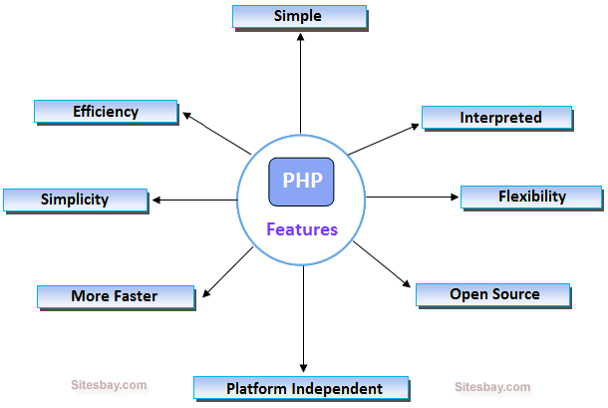

### Features of php

It is most popular and frequently used worldwide scripting language, the main reason of popularity is; It is open source and very simple.

### Simple

It is very simple and easy to use, compare to other scripting language it is very simple and easy, this is widely used all over the world.

### Interpreted

It is an interpreted language, i.e. there is no need for compilation.

### Faster

It is faster than other scripting language e.g. asp and jsp.

### Open Source

Open source means you no need to pay for use php, you can free download and use.

### Platform Independent

PHP code will be run on every platform, Linux, Unix, Mac OS X, Windows.

### Case Sensitive

PHP is case sensitive scripting language at time of variable declaration. In PHP, all keywords (e.g. if, else, while, echo, etc.), classes, functions, and user-defined functions are NOT case-sensitive.

### Error Reporting

PHP have some predefined error reporting constants to generate a warning or error notice.

### Real-Time Access Monitoring

PHP provides access logging by creating the summary of recent accesses for the user.

### Loosely Typed Language

PHP supports variable usage without declaring its data type. It will be taken at the time of the execution based on the type of data it has on its value.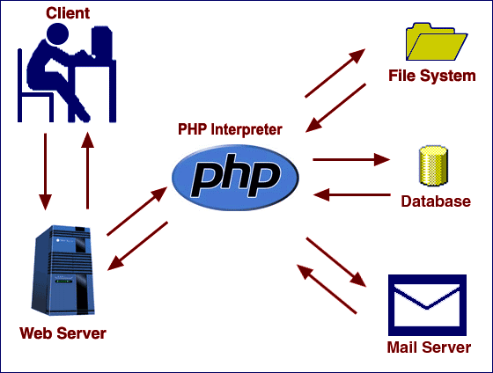

# PHP - Variable Types

The main way to store information in the middle of a PHP program is by using a variable.

Here are the most important things to know about variables in PHP.

* All variables in PHP are denoted with a leading dollar sign ($).
* The value of a variable is the value of its most recent assignment.
* Variables are assigned with the = operator, with the variable on the left-hand side and the expression to be evaluated on the right.
* Variables can, but do not need, to be declared before assignment.
* Variables in PHP do not have intrinsic types - a variable does not know in advance whether it will be used to store a number or a string of characters.
* Variables used before they are assigned have default values.
* PHP does a good job of automatically converting types from one to another when necessary.
* PHP variables are Perl-like.

## Variable Scope

Scope can be defined as the range of availability a variable has to the program in which it is declared. PHP variables can be one of four scope types −

* [Local variables](https://www.tutorialspoint.com/php/php_local_variables.htm)
* [Function parameters](https://www.tutorialspoint.com/php/php_function_parameters.htm)
* [Global variables](https://www.tutorialspoint.com/php/php_global_variables.htm)
* [Static variables](https://www.tutorialspoint.com/php/php_static_variables.htm)

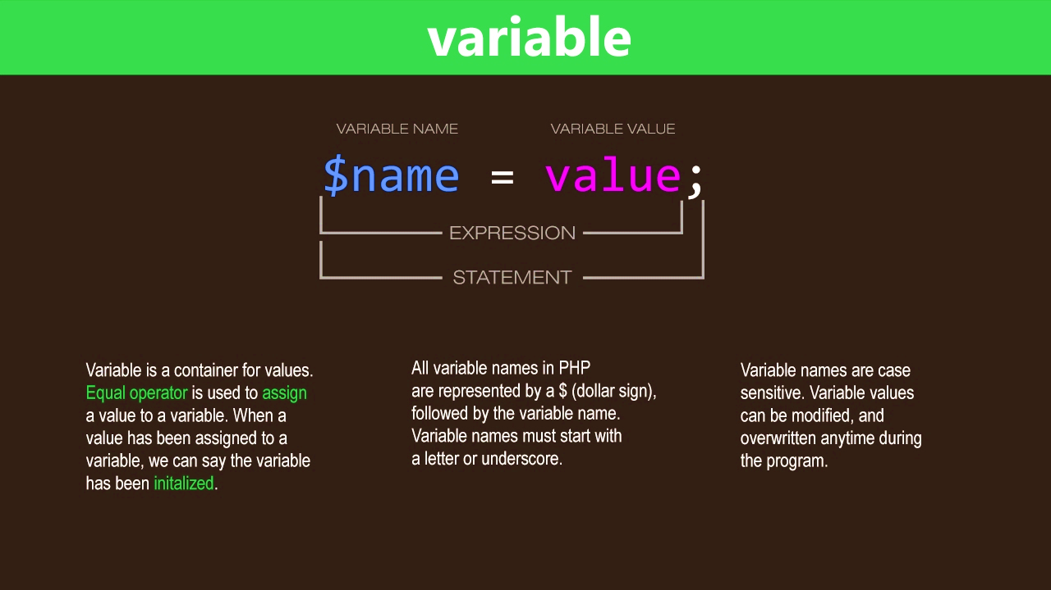

1. **HTML** (Hyper Text Markup Language)

HTML is a computer language devised to allow website creation. These websites can then be viewed by anyone else connected to the Internet. It is relatively **easy to learn**, with the basics being accessible to most people in one sitting; and quite **powerful** in what it allows you to create. It is constantly undergoing revision and evolution to meet the demands and requirements of the growing Internet audience under the direction of the [**» W3C**](http://www.w3.org/), the organization charged with designing and maintaining the language.

The definition of HTML is **Hypertext Markup Language**.

* *Hypertext* is the method by which you move around on the web — by clicking on special text called **hyperlinks** which bring you to the next page. The fact that it is *hyper* just means it is not linear — i.e. you can go to any place on the Internet whenever you want by clicking on links — there is no set order to do things in.
* *Markup* is what **HTML tags** do to the text inside them. They mark it as a certain type of text (*italicized* text, for example).
* HTML is a *Language*, as it has code-words and syntax like any other language.

### How does it work?

HTML consists of a series of short **codes** typed into a text-file by the site author — these are the tags. The text is then **saved as a html file**, and **viewed through a**[**browser**](https://www.yourhtmlsource.com/starthere/glossary.html#browser), like *Internet Explorer* or *Netscape Navigator*. This browser reads the file and translates the text into a visible form, hopefully rendering the page as the author had intended. Writing your own HTML entails using tags correctly to create your vision. You can use anything from a rudimentary text-editor to a powerful graphical editor to create HTML pages.

### What are the tags up to?

The tags are what separate normal text from HTML code. You might know them as the words between the <angle-brackets>. They allow all the cool stuff like images and tables and stuff, just by telling your browser what to render on the page. Different tags will perform different functions. The tags themselves don’t appear when you view your page through a browser, but their effects do. The simplest tags do nothing more than apply formatting to some text, like this:

**<b>**these words will be bold**</b>**, and these will not.

In the example above, the <b> tags were wrapped around some text, and their effect will be that the contained text will be bolded when viewed through an ordinary web browser.

Throughout **HTML Source** I will be teaching using the HTML 4.01 standard. The percentage of people using recently released browsers is high enough now for it to be safe to design sites using new HTML 4.01 elements and stylesheets. I’ll make sure that those who won’t see the optimum version of your site will still be able to use it, and wherever a relatively new piece of code is taught in a tutorial I will always refer to that in a browser compatibility box.

1. **CSS** (Cascading Style Sheets)

CSS Stands for "Cascading Style Sheet." Cascading style sheets are used to format the layout of [Web pages](https://techterms.com/definition/webpage). They can be used to define text styles, table sizes, and other aspects of Web pages that previously could only be defined in a page's [HTML](https://techterms.com/definition/html).

1. CSS helps Web developers create a uniform look across several pages of a Web site. Instead of defining the style of each table and each block of text within a page's HTML, commonly used styles need to be defined only once in a CSS document. Once the style is defined in cascading style sheet, it can be used by any page that references the CSS file. Plus, CSS makes it easy to change styles across several pages at once. For example, a Web developer may want to increase the default text size from 10pt to 12pt for fifty pages of a Web site. If the pages all reference the same style sheet, the text size only needs to be changed on the style sheet and all the pages will show the larger text.

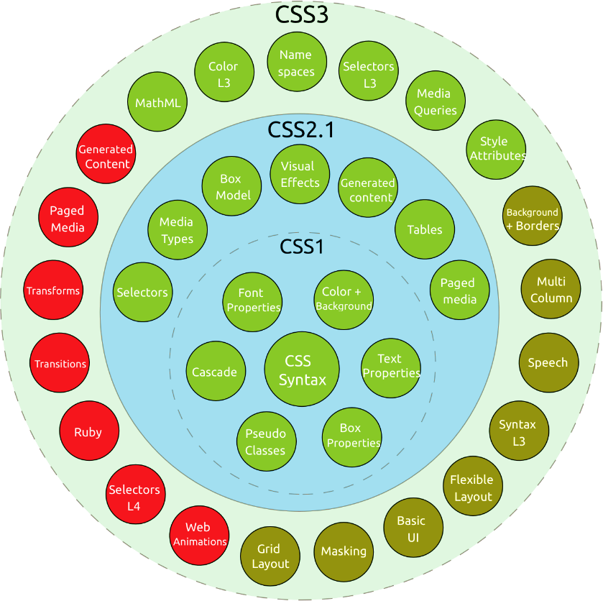

**4. Bootstrap**

A bootstrap is the program that initializes the operating system (OS) during startup. The term bootstrap or bootstrapping originated in the early 1950s. It referred to a bootstrap load button that was used to initiate a hardwired bootstrap program, or smaller program that executed a larger program such as the OS. The term was said to be derived from the expression “pulling yourself up by your own bootstraps,” starting small and loading programs one at a time while each program is “laced” or connected to the next program to be executed in sequence.

Bootstrapping is the process of loading a set of instructions when a computer is first turned on or booted. During the startup process, diagnostic tests are performed, such as the power-on self-test (POST) that set or check configurations for devices and implement routine testing for the connection of peripherals, hardware and external memory devices. The bootloader or bootstrap program is then loaded to initialize the OS.

Typical programs that load the OS are:

* GNU Grand Unified Bootloader (GRUB): A multiboot specification that allows the user to choose one of several OSs
* NT Loader (NTLDR): A bootloader for Microsoft’s Windows NT OS that usually runs from the hard drive
* Linux Loader (LILO): A bootloader for Linux that generally runs from a hard drive or floppy disc
* Network Interface Controller (NIC): Uses a bootloader that supports booting from a network interface such as Etherboot or pre-boot execution environment (PXE)

Prior to bootstrapping a computer is said to start with a blank main memory. The bootstrap allows the sequence of programs to load in order to initiate the OS. The OS is the main program that manages all programs that run on a computer and performs tasks such as controlling peripheral devices like a disc drive, managing directories and files, transmitting output signals to a monitor and identifying input signals from a keyboard.

Bootstrap can also refer to preparing early programming environments incrementally to create more complex and user-friendly programming environments. For example, at one time the programming environment might have consisted of an assembler program and a simple text editor. Over time, gradual improvements have led to today's sophisticated object-oriented programming languages and graphical integrated development environments (IDEs).

**5. JavaScript**

JavaScript is a language commonly used in [web development](https://techterms.com/definition/web_development). It was originally developed by Netscape as a means to add dynamic and interactive elements to websites. While JavaScript is influenced by [Java](https://techterms.com/definition/java), the [syntax](https://techterms.com/definition/syntax) is more similar to [C](https://techterms.com/definition/cplusplus) and is based on ECMAScript, a scripting language developed by Sun Microsystems.0

JavaScript is a client-side scripting language, which means the [source code](https://techterms.com/definition/sourcecode) is processed by the client's [web browser](https://techterms.com/definition/web_browser) rather than on the [web server](https://techterms.com/definition/web_server). This means JavaScript [functions](https://techterms.com/definition/function)can run after a webpage has loaded without communicating with the server. For example, a JavaScript function may check a web form before it is submitted to make sure all the required [fields](https://techterms.com/definition/field) have been filled out. The JavaScript code can produce an error message before any information is actually transmitted to the server.

Like server-side scripting languages, such as [PHP](https://techterms.com/definition/php) and [ASP](https://techterms.com/definition/asp), JavaScript code can be inserted anywhere within the [HTML](https://techterms.com/definition/html) of a [webpage](https://techterms.com/definition/webpage). However, only the [output](https://techterms.com/definition/output) of server-side code is displayed in the HTML, while JavaScript code remains fully visible in the source of the webpage. It can also be referenced in a separate [.JS](https://fileinfo.com/extension/js) file, which may also be viewed in a browser.

Below is an example of a basic JavaScript function that adds two numbers. The function is called with the parameters 7 and 11. If the code below were included in the HTML of a webpage, it would display the text "18" in an [alert box](https://techterms.com/definition/alertbox).

JavaScript functions can be called within <script> tags or when specific events take place. Examples include onClick, onMouseDown, onMouseUp, onKeyDown, onKeyUp, onFocus, onBlur, onSubmit, and many others. While standard JavaScript is still used for performing basic client-side functions, many web developers now prefer to use JavaScript libraries like [jQuery](https://techterms.com/definition/jquery) to add more advanced dynamic elements to websites.

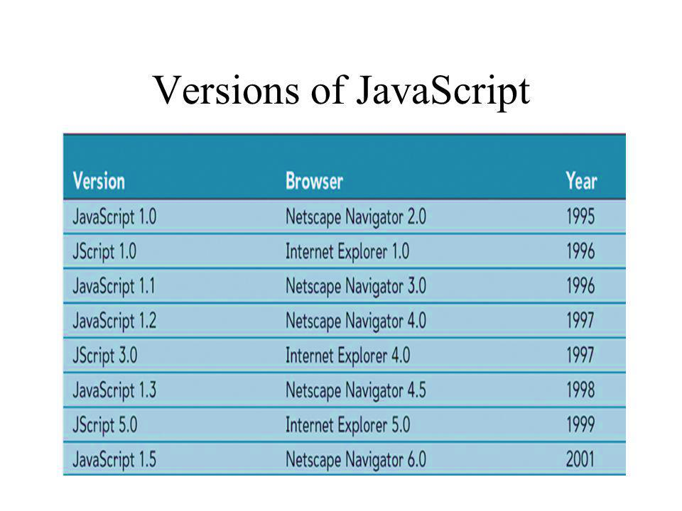

**6. My SQL** (Database Management through XAMPPServer)

My SQL is the world’s most popular open source database, enabling the cost-effective delivery of reliable, high-performance and scalable Web-based and embedded database applications. It is an integrated transaction safe, ACID-compliant database with full commit, rollback, crash recovery, and row-level locking capabilities. My SQL delivers the ease of use, availability, and high performance, as well as a full suite of database drivers and visual tools to help developers and DBAs build and manage their business-critical My SQL applications. My SQL is developed, distributed, and supported by Oracle, and the latest information about My SQL software can be found on the My SQL [Web site](http://www.mysql.com/). The My SQL database provides the following features:

* High Performance and Scalability to meet the demands of exponentially growing data loads and users.
* Self-healing Replication Clusters to improve scalability, performance and availability.
* Online Schema Change to meet changing business requirements.
* Performance Schema for monitoring user- and application-level performance and resource consumption.
* SQL and No SQL Access for performing complex queries and simple, fast Key Value operations.
* Platform Independence giving you the flexibility to develop and deploy on multiple operating systems.
* Big Data Interoperability using My SQL as the operational data store for Hardtop and Cassandra.

To achieve the highest level of My SQL scalability, security, and reliability and up time, [MySQL Enterprise Edition](http://www.mysql.com/products/enterprise/) includes the most comprehensive set of advanced features, management tools and technical support, including My SQL Enterprise Monitor, My SQL Enterprise Backup, as well as scalability, security, auditing and high availability features. My SQL Enterprise Edition also includes 24x7 Oracle Premier Support and Oracle product certifications and integration.

SQL is a standard language for accessing and manipulating databases.

**What is SQL?**

* SQL stands for Structured Query Language
* SQL lets you access and manipulate databases
* SQL became a standard of the American National Standards Institute (ANSI) in 1986, and of the International Organization for Standardization (ISO) in 1987

## What Can SQL do?

* SQL can execute queries against a database
* SQL can retrieve data from a database
* SQL can insert records in a database
* SQL can update records in a database
* SQL can delete records from a database
* SQL can create new databases
* SQL can create new tables in a database
* SQL can create stored procedures in a database
* SQL can create views in a database
* SQL can set permissions on tables, procedures, and views

**XAMPPSERVER (v3.2.3)**

**XAMP stands for**– Window Apache My SQL and PHP.  
**Developed by**– Romain Bourdon  
**Operating system**– Windows  
XAMPP is a mini web server that runs on almost any Windows operating system. XAMPP has Apache, PHP (SMTP ports are disabled), and My SQL (phpMyAdmin and SQLite manager are installed to manage the user’s databases) pre-installed. XAMPP is widely used and relied upon for local development or as a ready-to-deploy server. The ease of installation, configuration and management of XAMPP has played a vital role in its worldwide popularity.

**The core functionalities of XAMPP are:**

1. Effectively manage and administer your Apache server and services.
2. Take control over your My SQL database and related services.
3. Work in either *Online* or *Offline* mode.
4. Control all the server settings.
5. Keep a watch on the log files.
6. Create aliases and control permissions.

Upon installation, an icon on the taskbar tray displays XAMPP’s status – which lets the user know if:

1. XAMPP is running but no services are opened (the icon will appear red)
2. XAMPP is running and one service is opened (the icon will appear yellow)
3. XAMPP is running with all services opened (the icon will appear green)

Apache and My SQL are considered to be services. They can be disabled by left-clicking the taskbar icon, placing the cursor over the service to be disabled, and selecting “Stop Service”.

The files/web pages that are hosted on a XAMPP server can be accessed by typing [**http://localhost**](http://localhost/)or [**http://127.0.0.1**](http://127.0.0.1/)in the web browser’s address bar. XAMPP must be running in order to access either of the above addresses.

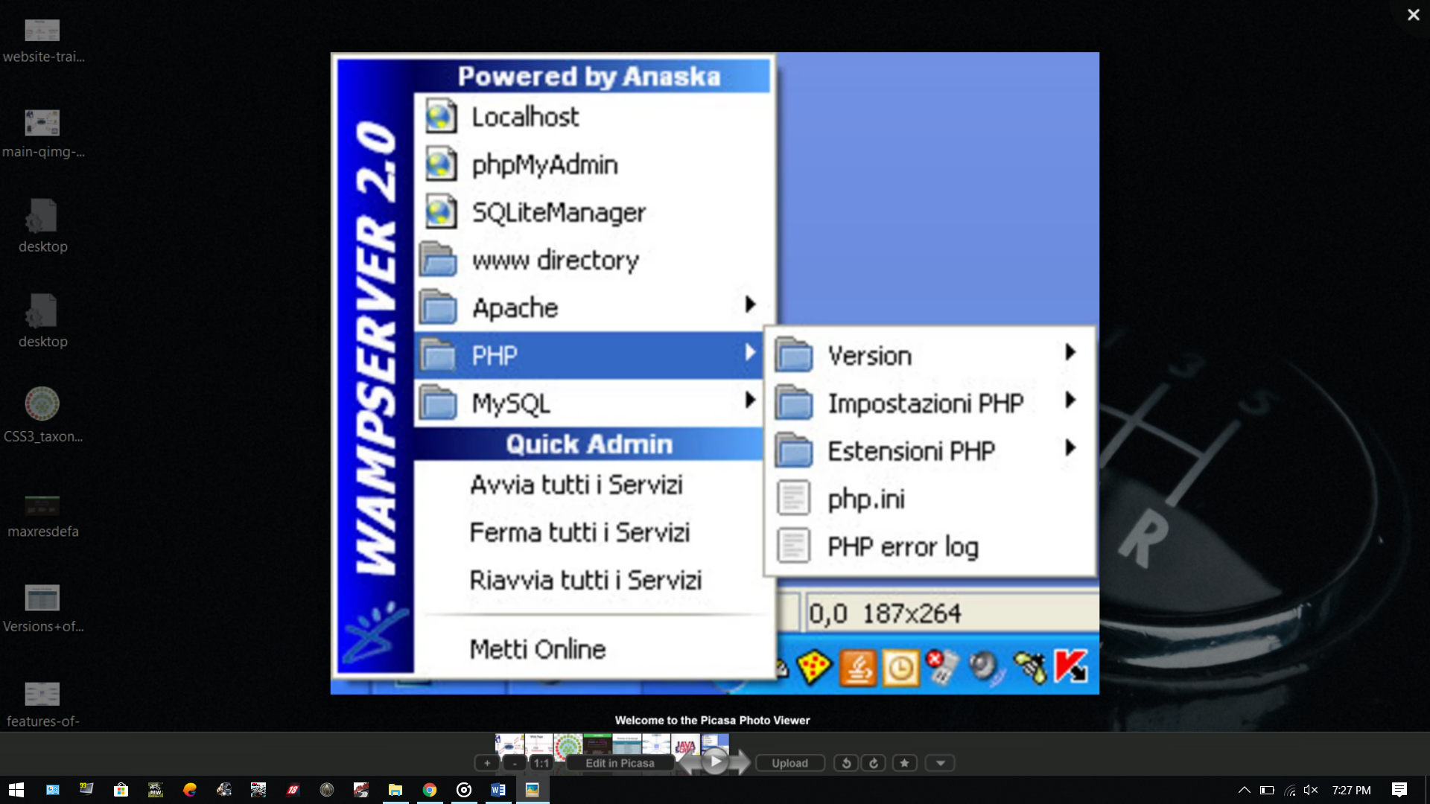

**REQUIREMENT ANALYSIS**

* **Hardware requirements:**
* **Processor:** Intel dual core or above
* **Processor Speed:**1.0GHZ or above
  + **RAM:** 1 GB RAM or above
  + **Hard Disk:** 20 GB hard disk or above
* **Software requirements:**
* XAMPP Server for MySQL Database Connection.

**DESIGN PHASE**

Design becomes more and more important as the project becomes larger and more complex.  Once you complete the requirements, you will typically see a myriad of alternatives for construction. These alternatives include the tools and technology you will you utilize, the scalability of the solution, and the structure of the components you will build. The Design Phase is where you look at the many potential solutions and narrow down the choices to determine the most effective and efficient way to construct the solution. The Design Phase answers the questions about "how" you will build the best solution.

It includes Data flow diagrams, Flow charts, ER diagrams, Pseudo codes, Data dictionary.

DFD: A *data flow diagram* (*DFD*) maps out the flow of information for any process or system. It uses defined symbols like rectangles, circles and arrows, plus short text labels, to show data inputs, outputs, storage points and the routes between each destination.

In our project,

* 1. Below is a Data flow diagram of login system

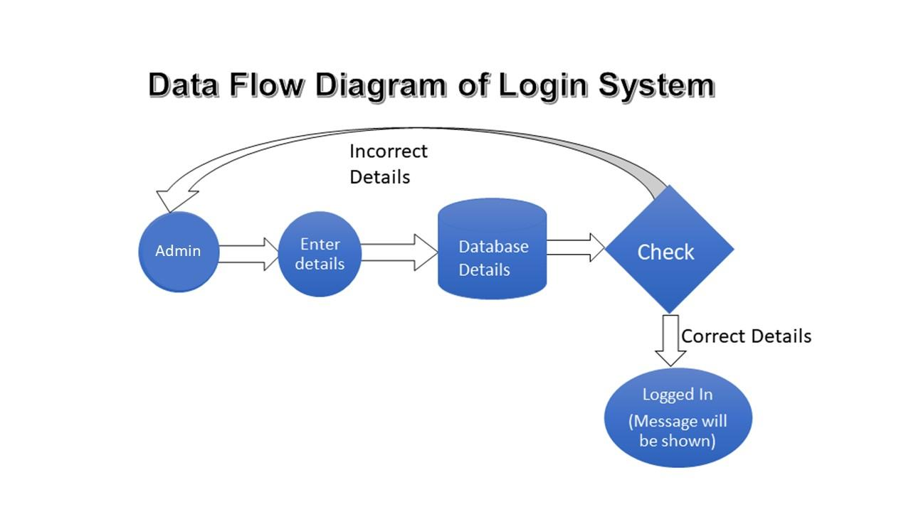

**ER DIAGRAMS**

An *entity relationship diagram* (ERD) shows the relationships of entity sets stored in a database. ... At first glance an *entity relationship diagram* looks very much like a flowchart. ... Common *Entity Relationship Diagram* Symbols. An Entity Relationship (ER) Diagram is a type of flowchart that illustrates how “entities” such as people, objects or concepts relate to each other within a system. ER Diagrams are most often used to design or debug relational databases in the fields of software engineering, business information systems, education and research. Also known as ERDs or ER Models, they use a defined set of symbols such as rectangles, diamonds, ovals and connecting lines to depict the interconnectedness of entities, relationships and their attributes. They mirror grammatical structure, with entities as nouns and relationships as verbs.

* + 1. Here is ER diagram for **Colleges**

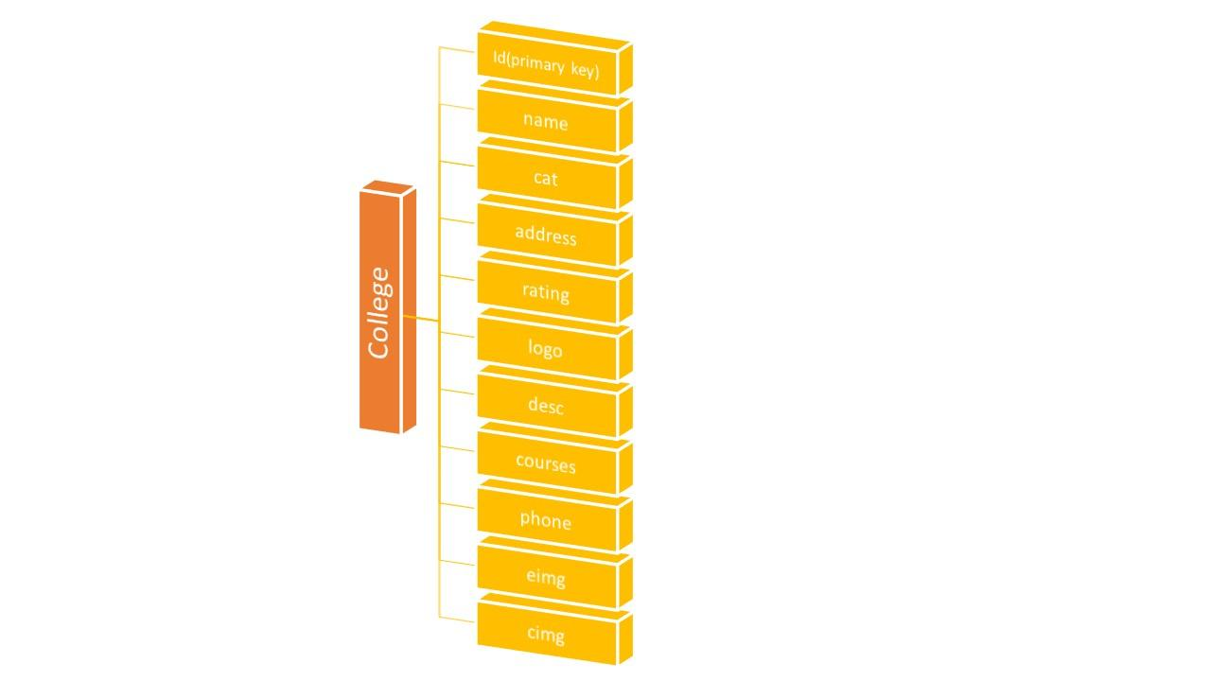

1. Below is ER diagram for **Student who want to apply for job.**

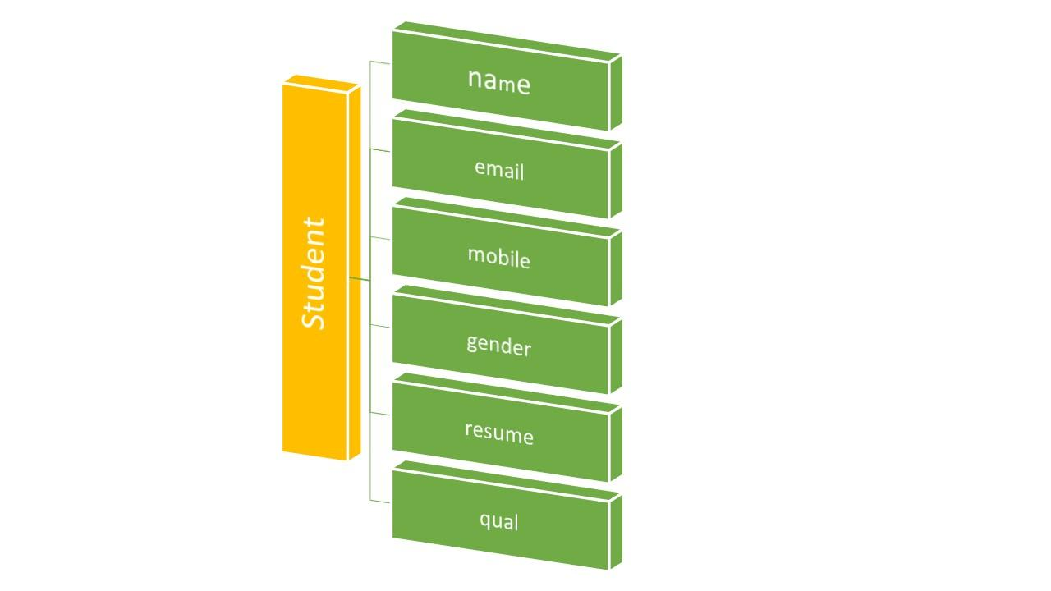

* 1. Following is the ER Diagram for Employer Registration

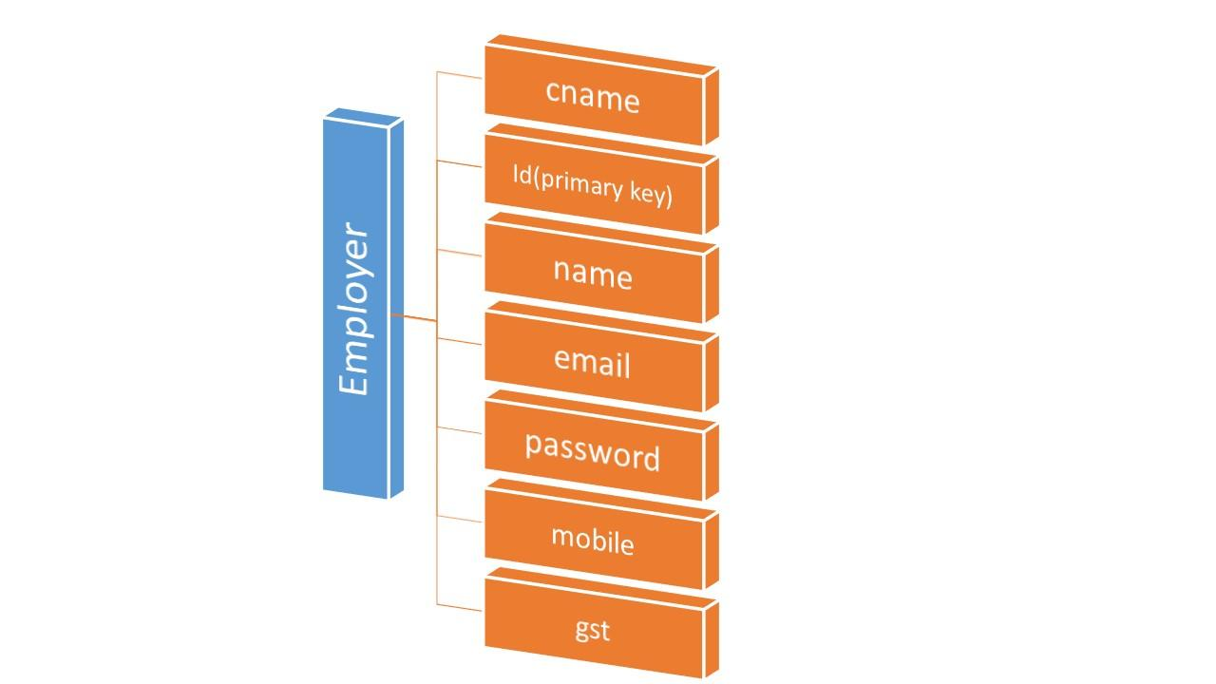

1. Below is ER diagram for **Jobs Details**

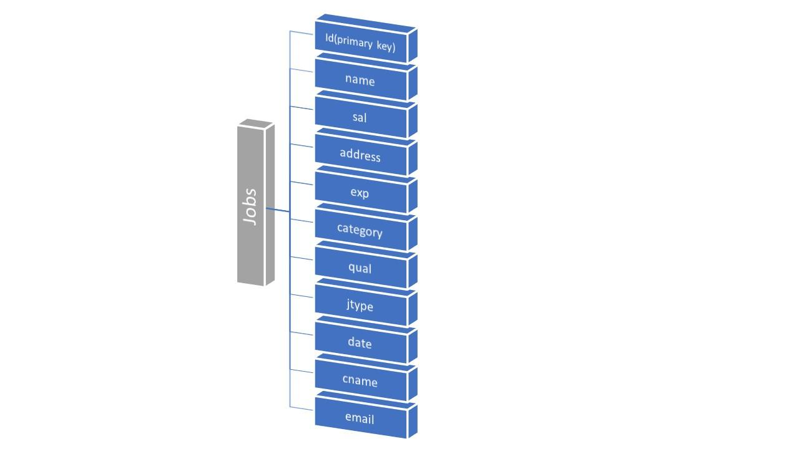

**SCREENSHOTS OF PROJECT**

1) HOME PAGE



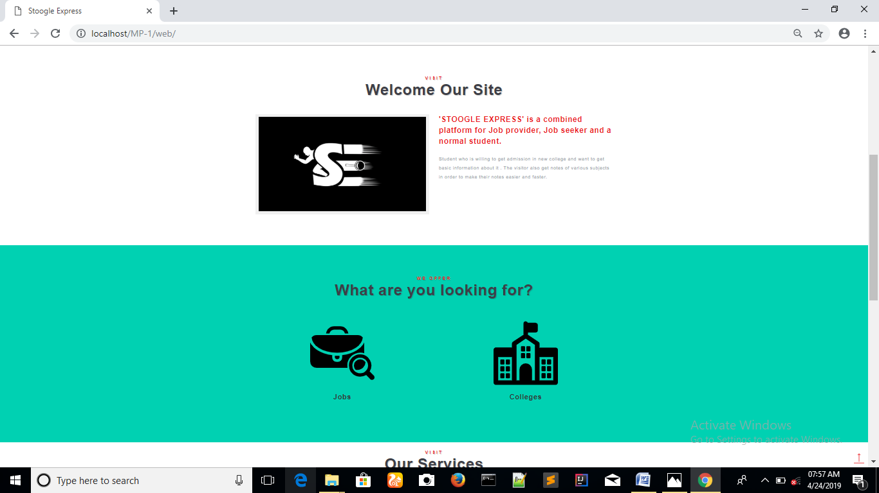

2) VIEW JOBS (JOBS HOME)

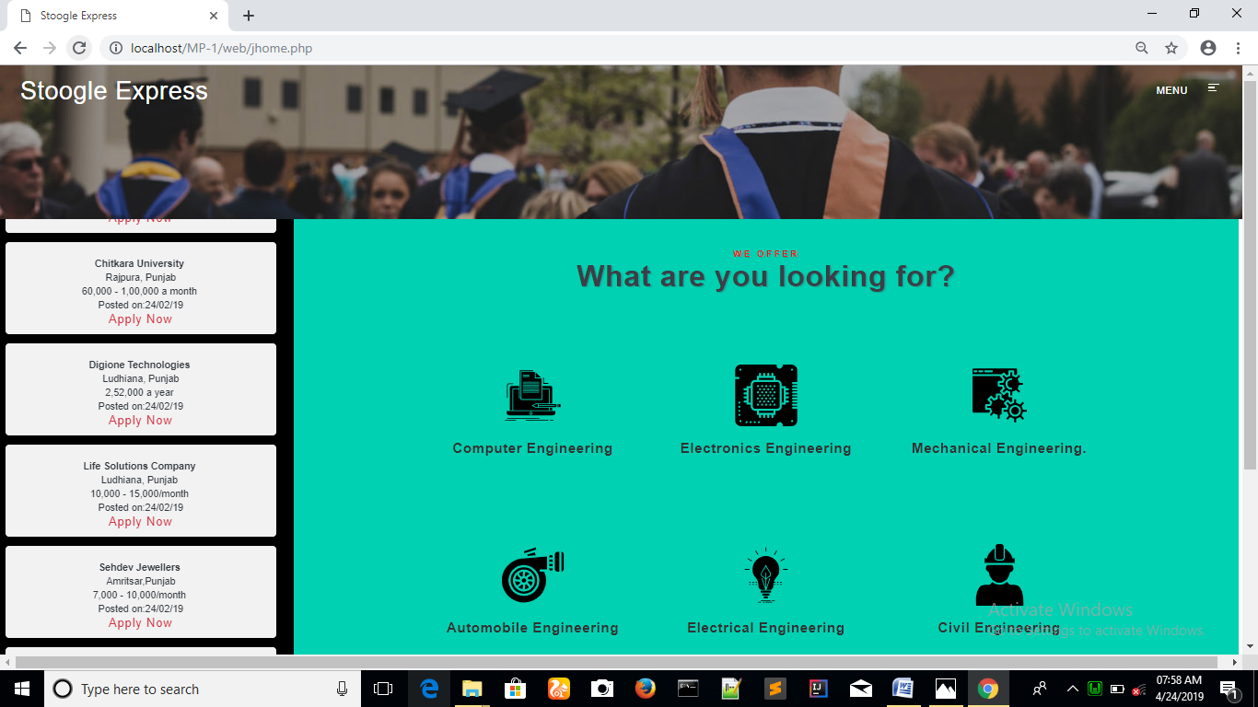

When we click on any category the below page will be displayed:-

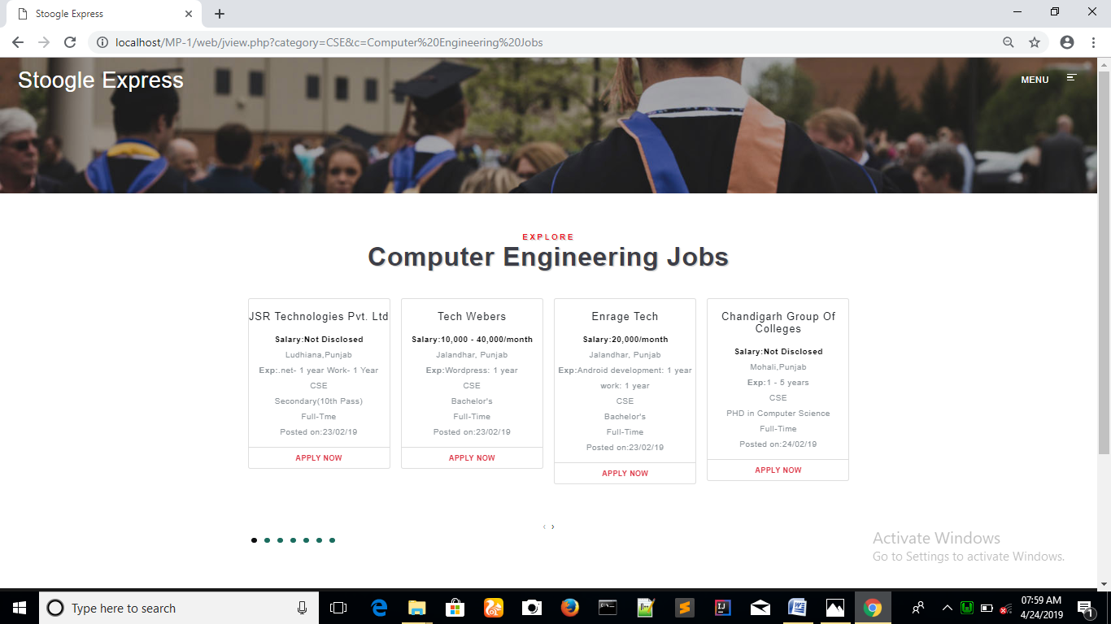

To apply for a job the user click on APPLY NOW link and page will be dispayed :-

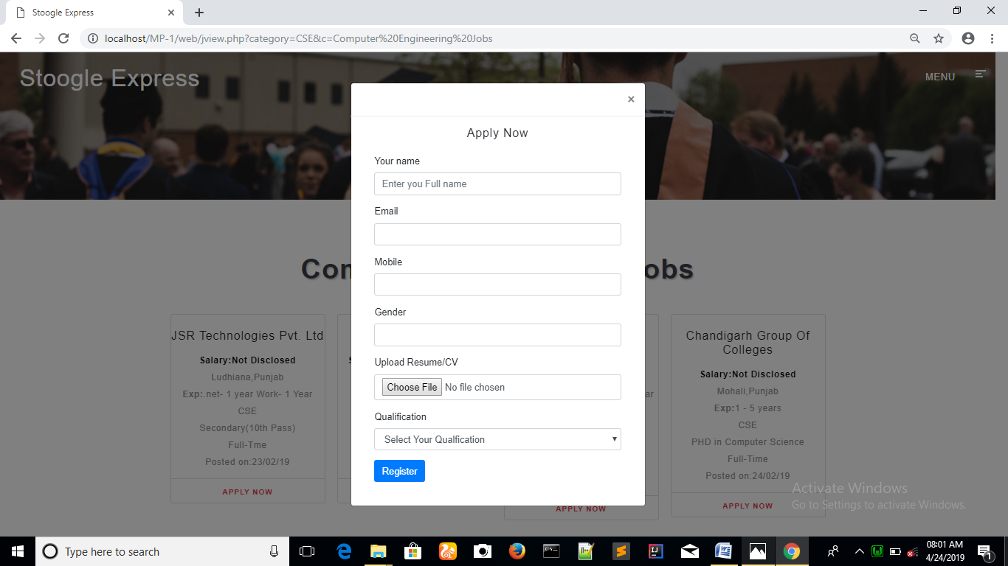

3)VIEW COLLEGES (COLLEGE HOME)



When we click on any category of college , the below page displayed :-

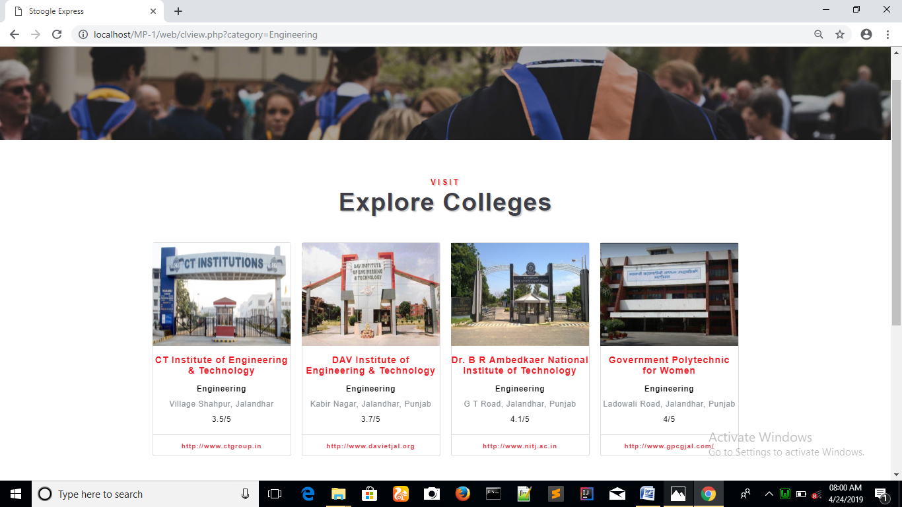

4)EVENTS INFORMATION

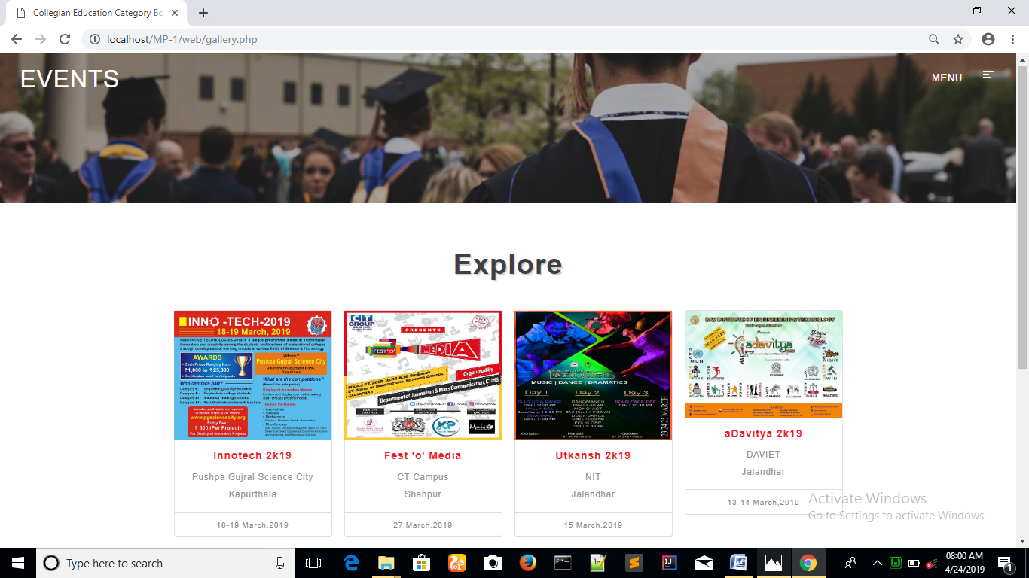

5) NOTES INFORMATION

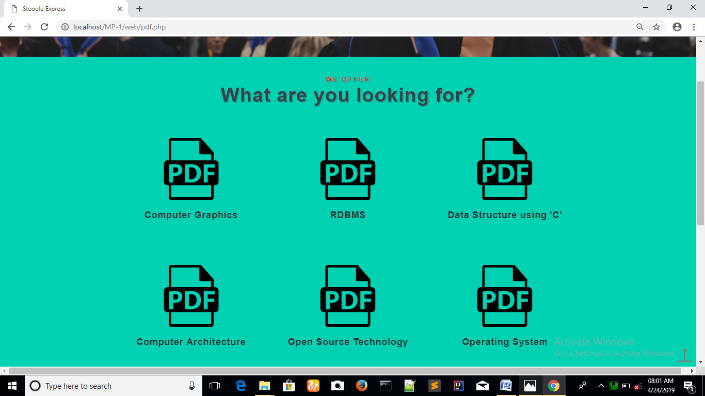

6) EMPLOYER REGISTERATION

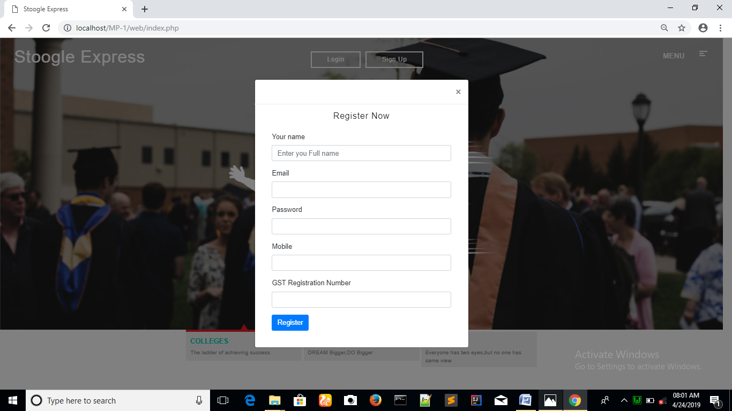

7) EMPLOYER HOME (VIEW APPLICANTS)

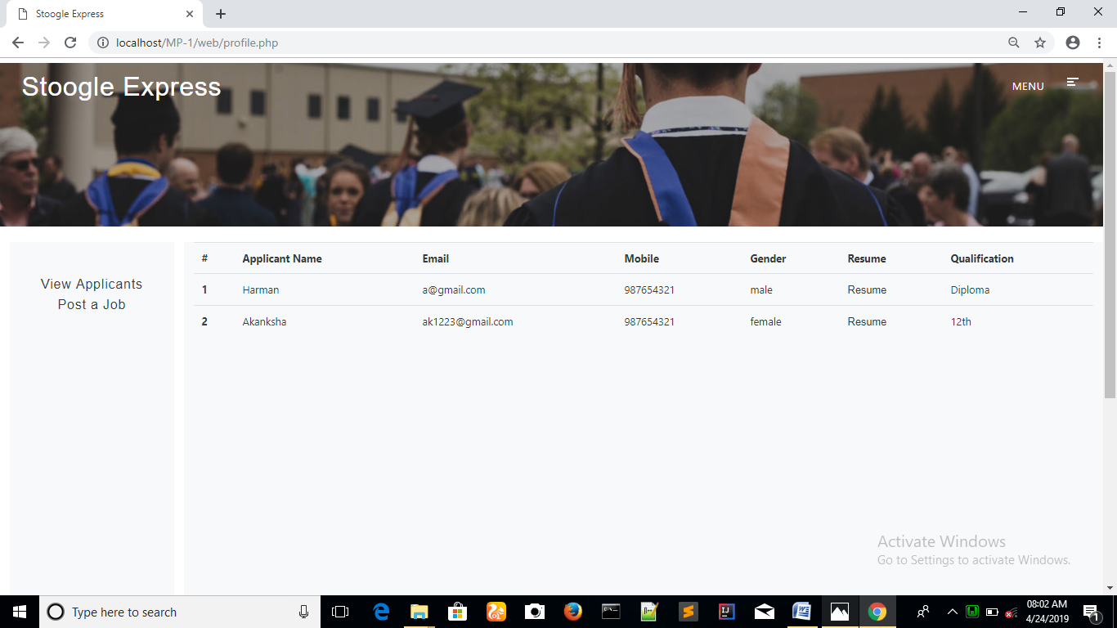

8) POST A NEW JOB

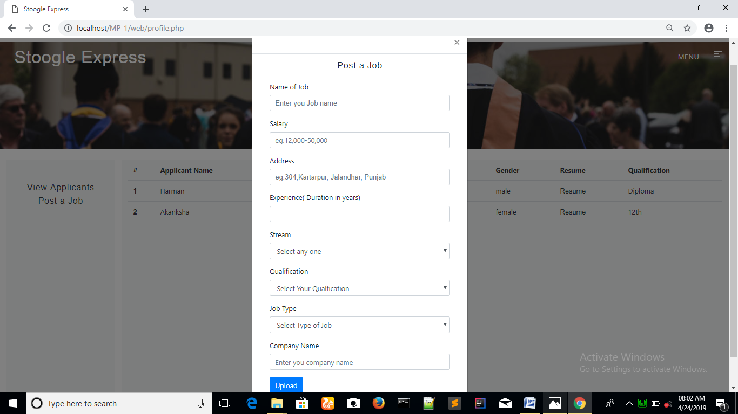

**CONCLUSION**

We have tried our best to make the process of searching and finding jobs and looking for various colleges or institutions a lot easier by combining the information and data of jobs and institutions together. We also have tried to design the website in such a way that the user may not have any difficulty in using the website“STOOGLE EXPRESS” is basically a website for searching and finding jobs. Not only that, but students can look for various institutions/colleges for admission also. We have tried our best to make the process of searching and finding jobs and looking for various colleges or institutions a lot easier by combining the information and data of jobs and institutions together. As we know, nowadays finding a job or searching for an institution information has become sort of a headache because there are many false and misleading websites that distribute wrong and incorrect data and information about various things. So in order to fix that and provide necessary and genuine information about jobs and institutions, we have made our website.

**References**

* <https://en.wikipedia.org/wiki/HTML>
* <https://www.w3schools.com/css/css_intro.asp>
* <http://getbootstrap.com/>
* <https://en.wikipedia.org/wiki/JavaScript>
* <https://www.tutorialspoint.com/php/>
* <https://www.yourhtmlsource.com/starthere/historyofhtml.html>